Colin Keenan

ECE 4203

3-3-2020

**Project 1**

Inverter Schematic

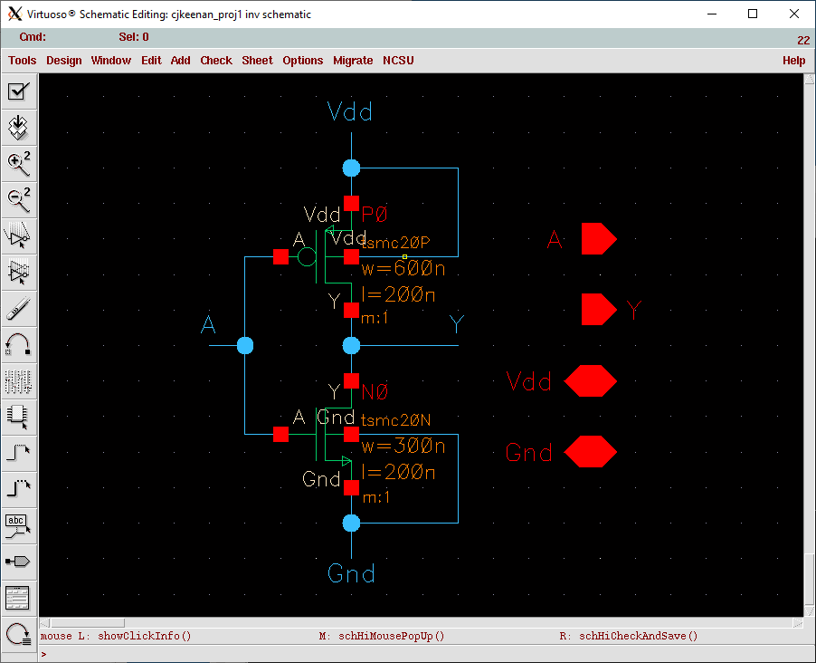

Inverter Symbol

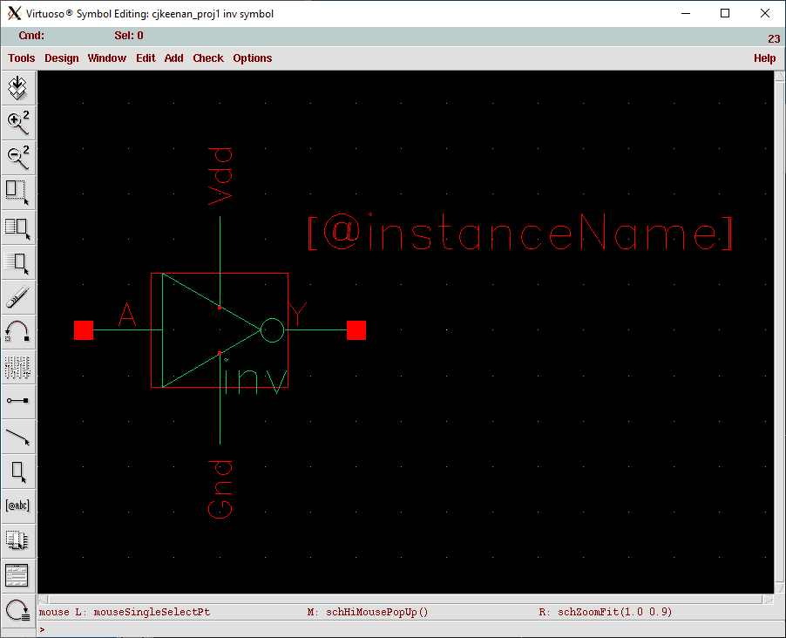

NAND3 Specification

|  |  |  |
| --- | --- | --- |
| Gate | NMOS Wn (in nm) | PMOS Wn (in nm) |
| NAND3 | 1200 | 1200 |

NAND3 Schematic

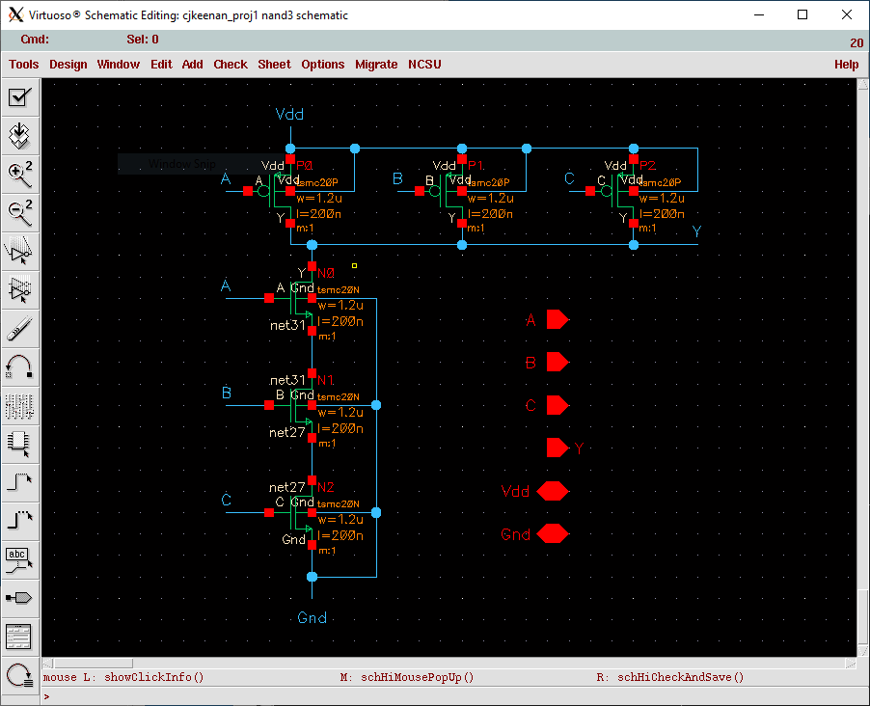

NAND3 Symbol

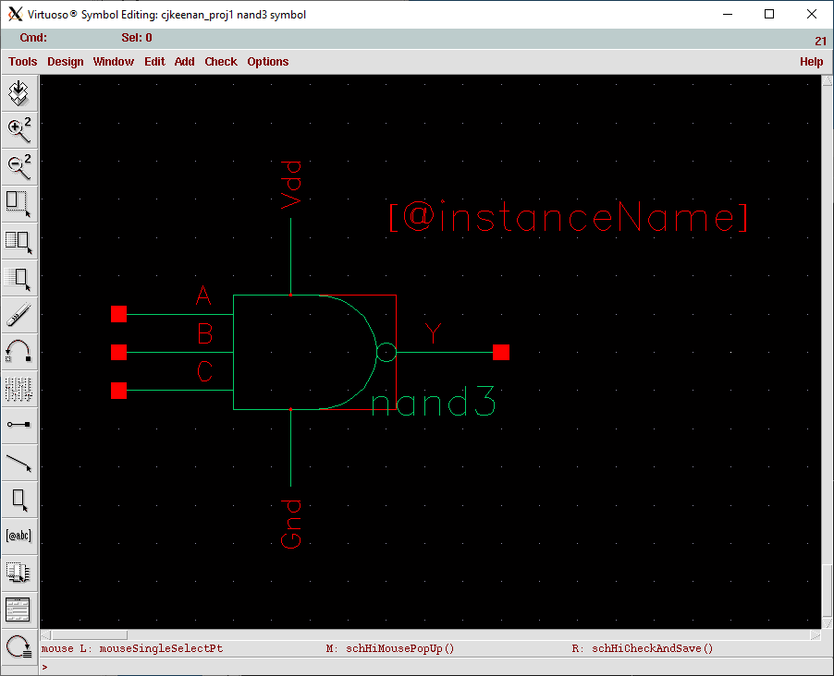

NAND3 Layout

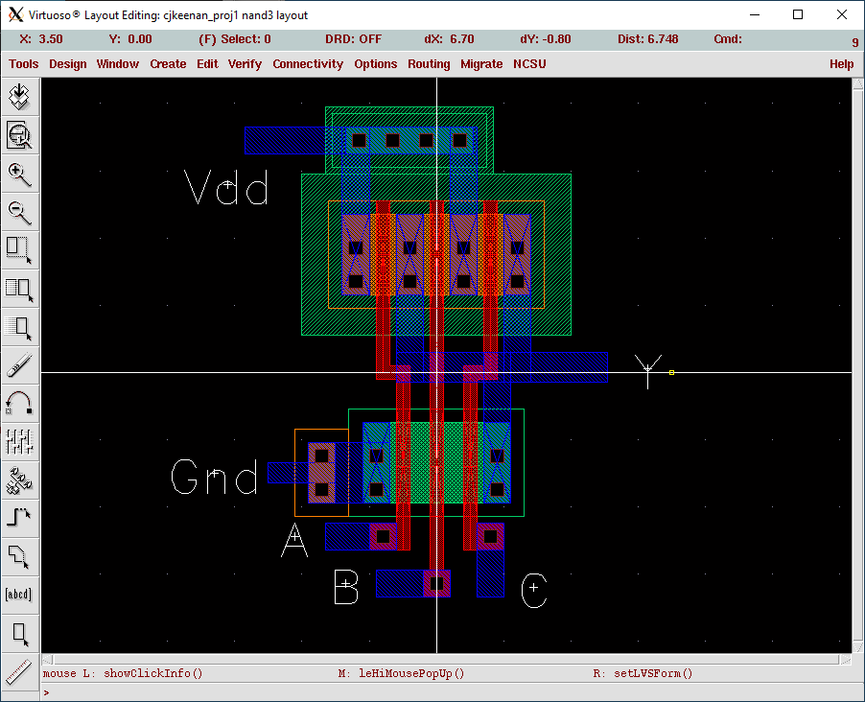

NAND3 DRC Clean

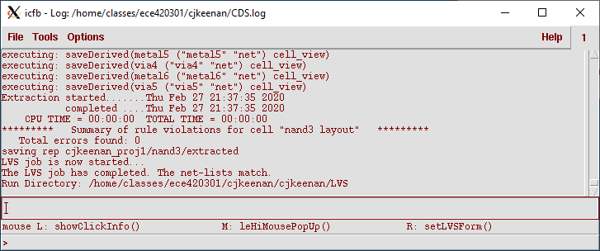

NAND3 LVS Netlist Output

